Kebi Hong

CS 455 Lab 3

12/9/15

1. 48-bit Ethernet address of my computer: 0c:84:dc:9c:df:6b
2. destination address in the Ethernet frame : 20:0c:c8:0f:61:de

No, this is not the Ethernet address of gaia.cs.umass.edu.

This is the address of my local router.

1. Hexadecimal value: 0800

Upper layer: IP

1. It is 54 bytes from the start of the Ethernet frame
2. The Ethernet source address is 20:0c:c8:0f:61:de

No, this address is the router that my computer connected to

1. The destination address is 0c:84:dc:9c:df:6b, this is the address of my computer
2. Hexadecimal value for the Frame type field = 0x0800, the upper layer protocol is IP
3. It is 13 bytes from the start of the Ethernet frame

**The Address Resolution Protocol**

1. 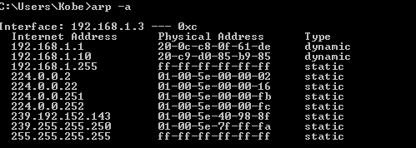

It displays all the internet address that I can connect to. Internet address is the internet address on other devices. Physical address is the Ethernet address of other devices.

1. Source = 90:8d:6c:d2:8a:7c

Destination = ff:ff:ff:ff:ff:ff

1. 0x0806. Upper layer protocol is ARP
2. (a). 48 bytes from the beginning of the frame

(b).

(c). “Sender Mac address”: Apple_d2:8a:7c 90:8d:6c:d2:8a:7c

“Sender IP address” : 192.168.1.6

1. We can see the broadcast ARP because it is sent to everyone in the network, but we can’t see the reply because it is sent directly to the destination.